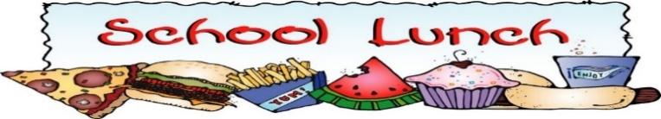
November 2025
Monday | Tuesday | Wednesday | Thursday | Friday
3rd Nov  Chicken Penne, Dice Vegetable  Fresh Fruit | 4th Nov  Turkey and Lettuce Sandwiches  Apples | 5th Nov  Stir Fried Rice  With Chicken & Veggies  Spring Roll | 6th Nov  Early Dismissal | 7th Nov  Roast Beef Sandwich  With Dill Pickles  Fresh Fruit
10th Nov  Fall Break | 11th Nov  Fall Break | 12th Nov  Fall Break | 13th Nov  Early Dismissal | 14th Nov  Quesadilla with Turkey Bacon Veggie, Cheese  Cherry Tomato
17th Nov  Chicken Alfredo  With Vegetables  & Pasta  Cream Puff | 18th Nov  Chicken Fingers  Potato Wedges  Fresh Veggie | 19th Nov  Roast Beef Sandwich  With Lettuce on Whole Wheat Bread  Fresh Fruit | 20th Nov  Early Dismissal | 21st Nov  Pastrami Sandwich  On Whole Wheat Bread  Corn Fritter
24th Nov  Mac N Cheese  With Dice Ham  Fresh Vegetable | 25th Nov  Ham & Cheese Sandwich  On Whole Wheat Bread  Dill pickle coin | 26th Nov  Southwest Chicken  With Veggies & Rice  Fresh Fruit | 27th Nov  Early Dismissal | 28th Nov  Meat lover’s Subs  Donut
*Please Note that menus are subject to change.

10th – 12th November – Fall Break

